SIMATS ENGINEERING - TOC ASSESSMENT SOLUTIONS

COURSE OUTCOME COVERED

CO1: Analyze fundamental mathematical concepts of automata theory for formal languages and decision problems.(BL:3)

Assessment Tool Weightage: 40%

QUESTIONS: 5 Total Marks:25
Duration : 1 Hour
Analytical Problem

Code of Conduct:

I Sanjay Manesh M (192511362) (Name / Reg No) certify that this submission is my original work and that I have adhered to the guidelines specified for this assessment.
I understand that any violation of academic integrity rules will result in disciplinary action.

Signature of the student:
Sanjay Manesh M

Question 1 — Convert the given NFA into an equivalent DFA

Solution. Given alphabet Σ = {a, b}, start state q0, and accepting state q2. The NFA transitions are read from the supplied question diagram.

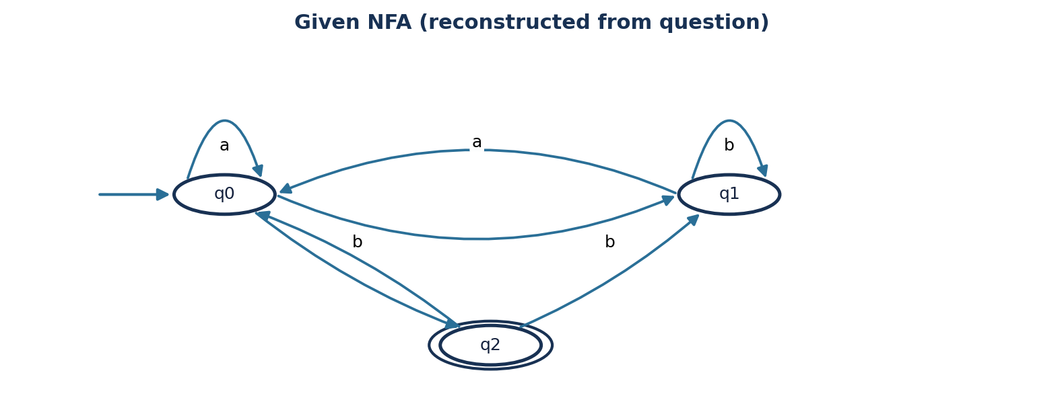

Original NFA Transition State
NFA state | Input a | Input b
→ q0 | {q0, q1} | {q2}
q1 | {q0} | {q1}
* q2 | ∅ | {q0, q1}

Subset construction – DFA Transition Table

DFA state | NFA subset | on a | on b | Status
→ A | {q0} | B | C | Rejected
B | {q0,q1} | B | D | Rejected
* C | {q2} | E | B | Accepted
* D | {q1,q2} | A | B | Accepted
E | ∅ | E | E | Dead

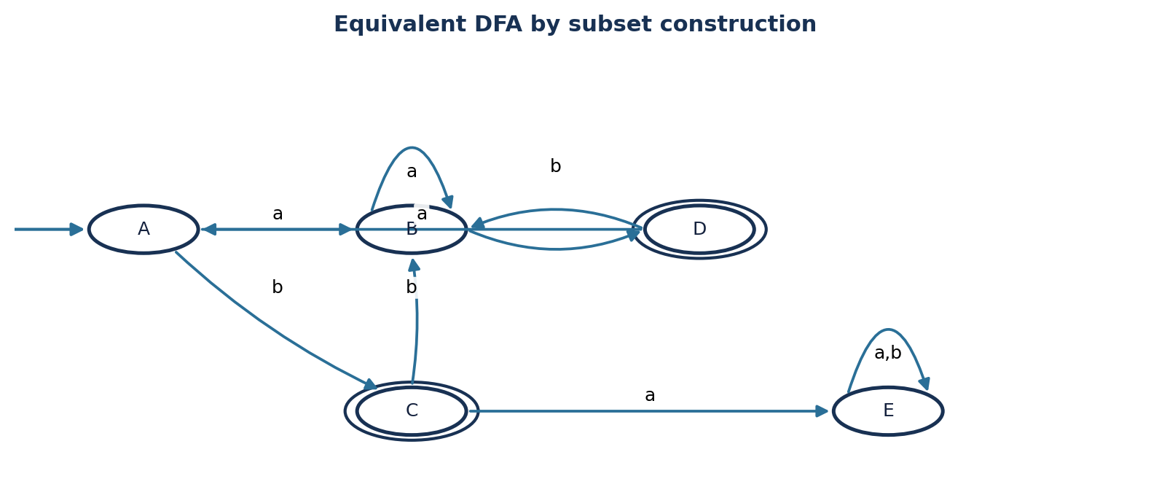
Figure 2. Equivalent DFA Transition Diagram

Question 2 — Strings of length at least 2 whose last two letters differ

Solution. Language: L = {w ∈ {a,b}* : |w| ≥ 2 and the final two symbols are ab or ba}.

A. NFA construction

The start state s loops on a and b to consume any prefix. The NFA can nondeterministically guess that the current a or b is the penultimate symbol, then consume the opposite symbol to reach final state f.
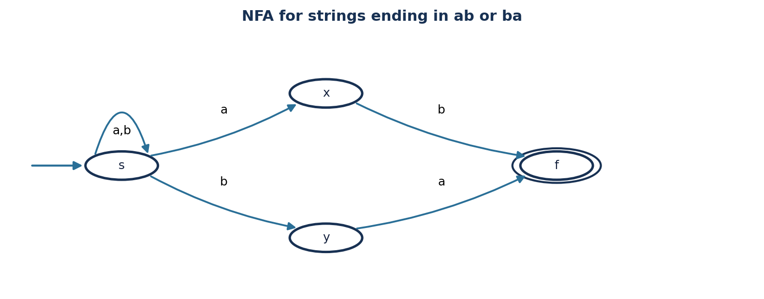
Figure 3. NFA for suffix ab or ba

NFA Transition Table
State | a | b
→ s | {s,x} | {s,y}
x | ∅ | {f}
y | {f} | ∅
* f | ∅ | ∅

B. Equivalent DFA

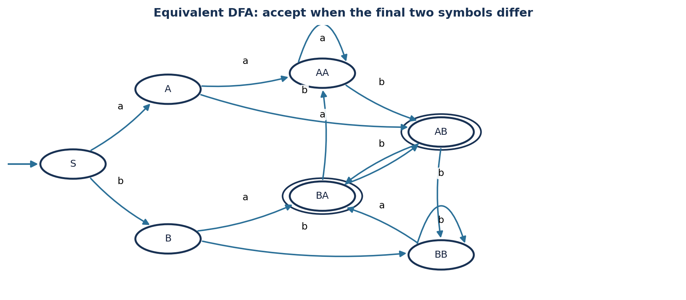
Figure 4. DFA. Only AB and BA are accepting states.
DFA state | Meaning | a | b | Accept?
→ S | Empty input so far | A | B | No
A | Suffix a (length 1) | AA | AB | No
B | Suffix b (length 1) | BA | BB | No
AA | Ends with aa | AA | AB | No
* AB | Ends with ab | BA | BB | Yes
* BA | Ends with ba | AA | AB | Yes
BB | Ends with bb | BA | BB | No

Question 3 — NFA for binary strings ending in 00 or 11

Solution. Alphabet Σ = {0,1}. The string is accepted only when its final two bits are equal; therefore the language is (0|1)*(00|11).

Formal definition
M = (Q, Σ, δ, q0, F), where Q = {q0,q1,q2,q3,q4}, Σ = {0,1}, start state q0, and F = {q2,q4}.

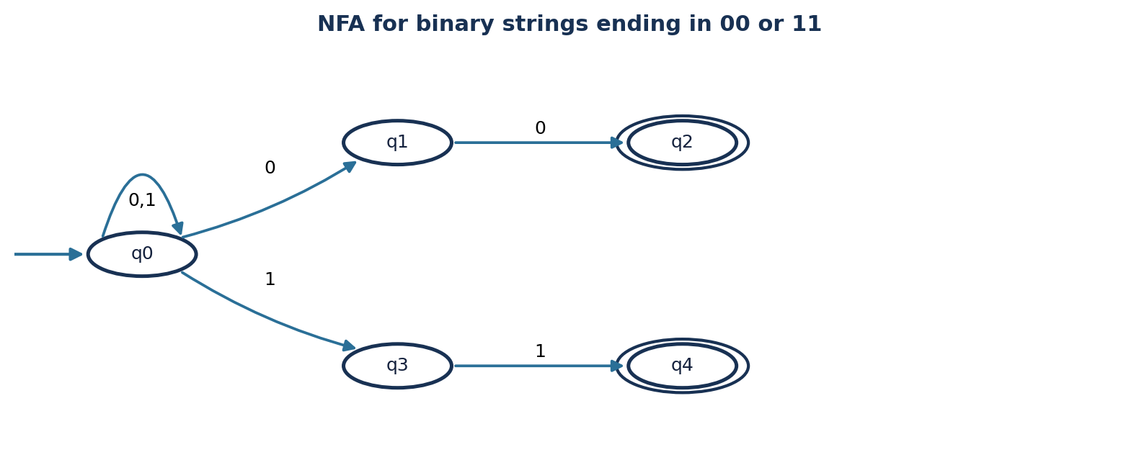
Figure 5. NFA for suffix 00 or 11
State | 0 | 1
→ q0 | {q0,q1} | {q0,q3}
q1 | {q2} | ∅
* q2 | ∅ | ∅
q3 | ∅ | {q4}
* q4 | ∅ | ∅

Binary Transition Table

Step | Symbol consumed | Chosen transition / state
Start | — | q0
1 | 0 | q0 → q0
2 | 1 | q0 → q0
3 | 0 | q0 → q0
4 | 1 | q0 → q3
5 | 1 | q3 → q4 (accepting state)

Question 4 — DFA for strings containing 001 as a substring

Solution. Alphabet Σ = {0,1}. The target language is L = {x001y : x,y ∈ {0,1}*}. The DFA tracks how much of the pattern 001 has been matched as a suffix.

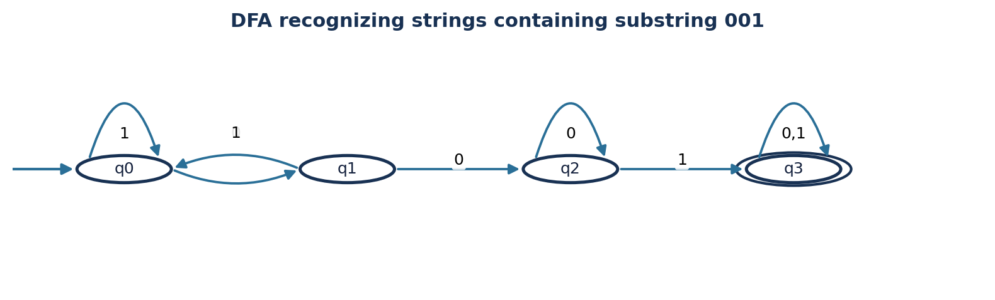
Figure 6. DFA recognizing substring 001
State | Interpretation | 0 | 1 | Status
→ q0 | No useful prefix matched | q1 | q0 | Non-final
q1 | Suffix 0 matched | q2 | q0 | Non-final
q2 | Suffix 00 matched | q2 | q3 | Non-final
* q3 | Substring 001 found | q3 | q3 | Final

Why the transitions work
- From q0, a 0 begins a possible match; a 1 cannot begin 001, so the machine stays in q0.
- From q1, another 0 gives suffix 00; a 1 breaks the match and returns to q0.
- From q2, input 1 completes 001. Input 0 keeps suffix 00, so q2 loops on 0.
- Once q3 is reached, the substring has already appeared; any remaining input is accepted.

Example
For 100101, the machine reaches q3 after reading the substring 001 and remains there, so the string is accepted. The string 01010 is rejected because it never contains 001.

Question 5 — ε-NFA to DFA conversion

Solution. The given ε-NFA has loops 1 at q0, 0 at q1, and 0,1 at q2, with ε-transitions q0 → q1 and q1 → q2. State q2 is final.

DFA subset transitions

The DFA start subset is ε-closure(q0) = {q0,q1,q2}. A subset is final if it contains q2. All reachable subsets in this conversion contain q2, so all reachable DFA states are accepting.

DFA state | NFA subset | on 0 | on 1 | Status
→ * A | {q0,q1,q2} | B | A | Final
* B | {q1,q2} | B | C | Final
* C | {q2} | C | C | Final

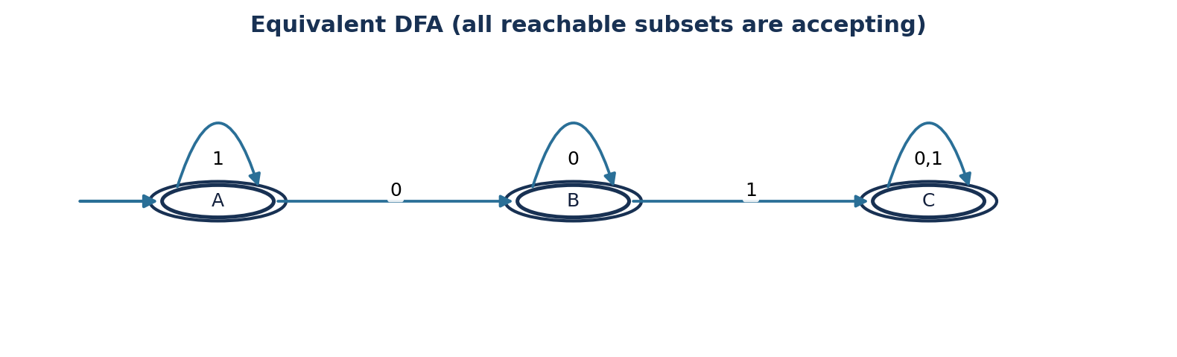
Figure 8. Equivalent DFA

